Carti Hotel Management System

Use-Case-Realization Specification: Check-out

Version <1.0>

Revision History

| **Date** | **Version** | **Description** | **Author** |
| --- | --- | --- | --- |
| 25/Nov/2024 | 1.0 | Final Version | Hoang Sinh Hung |
|  |  |  |  |
|  |  |  |  |
|  |  |  |  |

Table of Contents

1. Introduction 4

1.1 Purpose 4

1.2 Scope 4

1.3 Definitions, Acronyms, and Abbreviations 4

1.4 References 4

1.5 Overview 4

2. Flow of Events—Design 4

3. Derived Requirements 6

Use-Case-Realization Specification: Check-out

# Introduction

## Purpose

This document describes how the Check-out use-case is realized within the design model of the Carti Hotel Management System projects.

## Scope

This document applies to the Carti Hotel Management System.

## Definitions, Acronyms, and Abbreviations

None.

## References

None.

## Overview

The use case's design and corresponding requirements are detailed in the following sections. Specifically, the flow of events in the design section includes the realization of the use case through a class diagram and a sequence diagram, accompanied by a concise textual explanation. The subsequent section outlines the derived requirements that must be considered during the implementation of the use case.

# Flow of Events—Design

The two diagrams below illustrate the necessary classes and the sequence of interactions required to implement the Check-out use case.

On the Receptionist Page, the receptionist enters the customer’s name in the search bar and clicks the Search Button. The Search Controller invokes the searchCustomerName() function to find all customers matching the input. It then calls the getListOfCustomers() function to retrieve the list of matching customers and the showCustomers() function to display the results on the screen.

The receptionist selects a customer, and the system navigates to the Customer Detail Page. The Booking Controller fetches the reservation history of the selected customer by invoking the getReservationHistory() function and uses the showReservationHistory() function to display the data on the screen.

The receptionist selects a reservation and is navigated to the Reservation Detail Page. The Booking Controller invokes three functions: loadBill(), getBill(), and showBill() to load the reservation’s bill, fetch it from the database, and display it on the screen.

To complete the check-out process, the receptionist clicks the Check-Out Button. The checkOut() function is invoked to handle the check-out process, including updating the room’s availability using the updateRoomAvailability() function.

Finally, the receptionist clicks the Print Bill Button. This action prompts the Booking Controller to invoke the load Bill() function to load the bill, the getBill() function to retrieve the bill information from the database, and the printBill() function to generate a printed copy of the bill for the customer.

## Sequence diagram

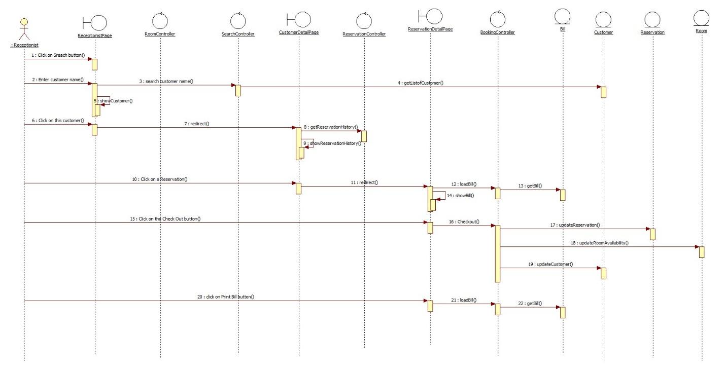

## Class diagram

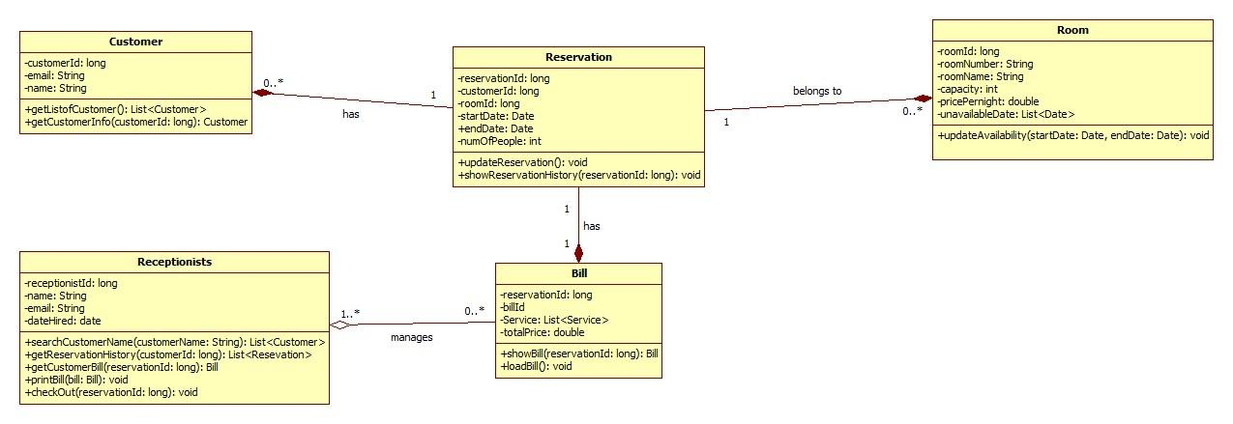

# Derived Requirements

None.